Drop Required User DB’s – (2) -- SQL Server.

--Below TSQL Script will kill all DB connections and delete all databases in the list.
--Ensure that before Dropping any DB, please take a Full DB Backup for safer side.
--Before dropping the below mentioned user databases.
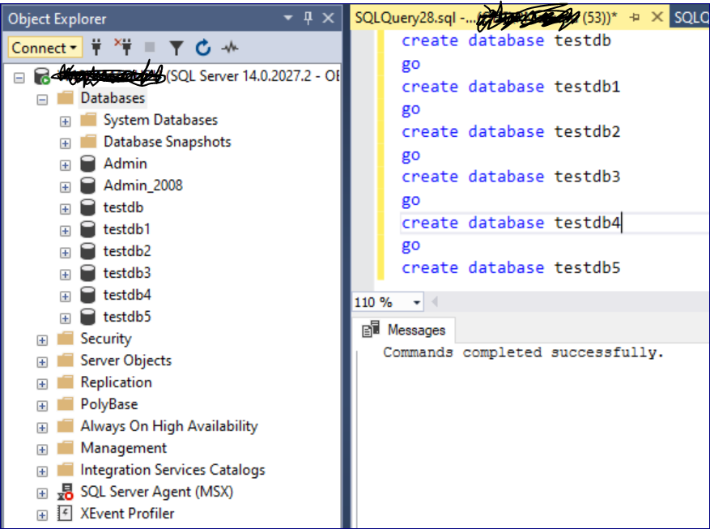

use [master]
go
DECLARE @DATABASENAME nVARCHAR(20)
DECLARE @TABLE TABLE (NAME NVARCHAR(100))
Declare @SQL nvarchar(100)

INSERT INTO @TABLE
SELECT name
FROM sys.databases
WHERE name in ('testdb','testdb1','testdb2','testdb3','testdb4','testdb5')
--specify the exact DB Names in above line which needs to be dropped.

while (select COUNT(*) from @table) > 0

begin
select @DATABASENAME = (select top 1 (name) from @TABLE)
DECLARE @kill varchar(8000) = '';

SELECT @kill = @kill + 'kill ' + CONVERT(varchar(5), spid) + ';'
FROM master..sysprocesses
WHERE dbid = db_id(@DATABASENAME)

EXEC(@kill);

set @SQL = 'drop database ' + @DATABASENAME
exec sp_executesql @SQL, N'@databasename nvarchar(100)', @databasename;

Print @databasename + ' has been deleted'

delete from @TABLE where NAME = @DATABASENAME

end

--After dropping the above-mentioned user databases.
